**An overview of the login functionality:**

Create an AuthenticationService and a Login component

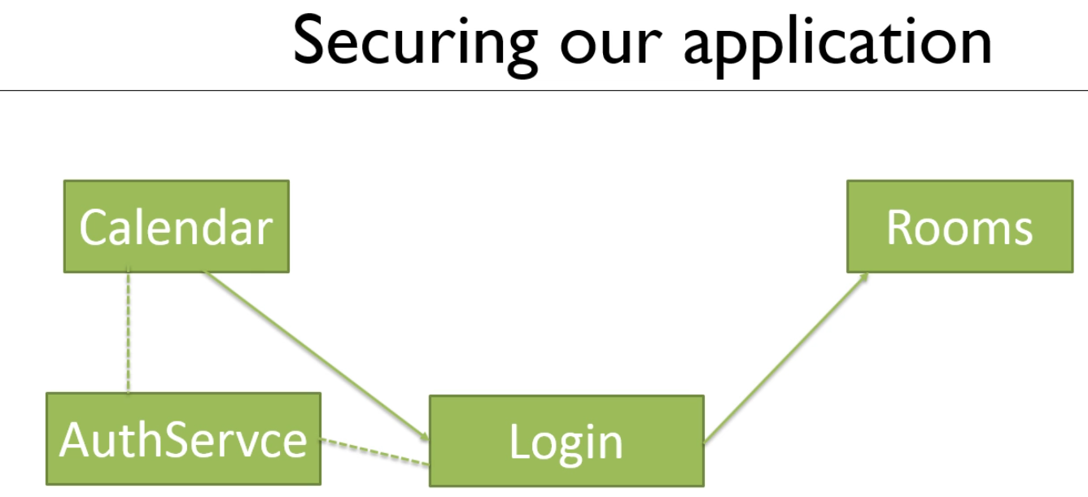

Create the AuthService

>ng g s Auth

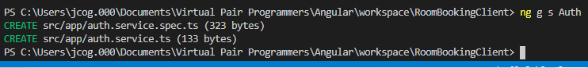

Added property Boolean isAuthenticated

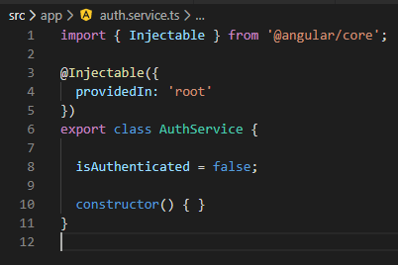

Create method authenticate()

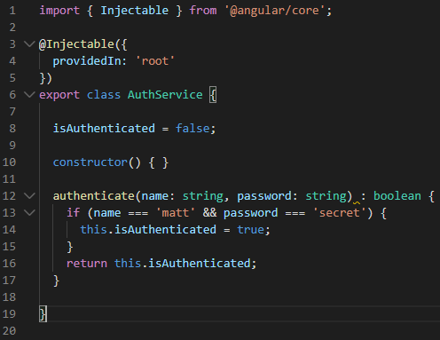

Now, create the login component

>ng g c login

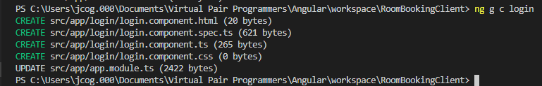

Copy the starting html from the provided component

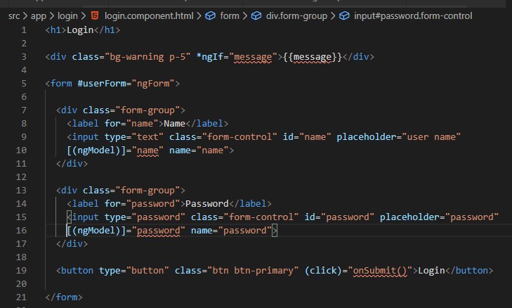

Add the message variable to the login-component.ts class file

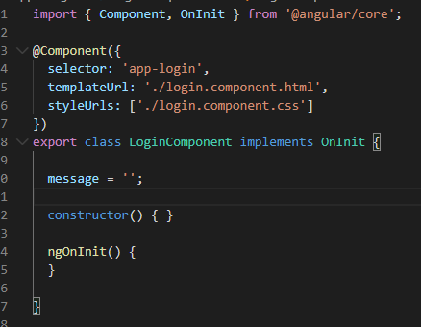

Create variables name, password and onSubmit() method

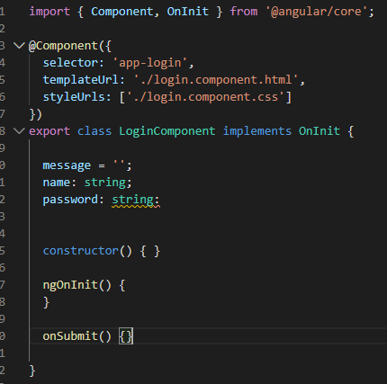

Now, fill out the onSubmit() method

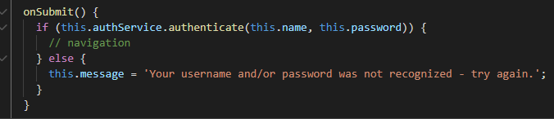

Now, let us create the redirection piece

This feature is called a rootGuard, a guarded route is created.

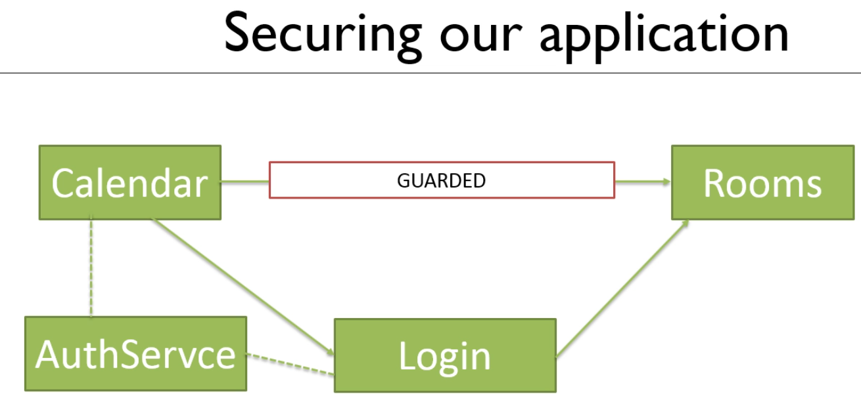

A rootGuard is a service that implements a specific interface

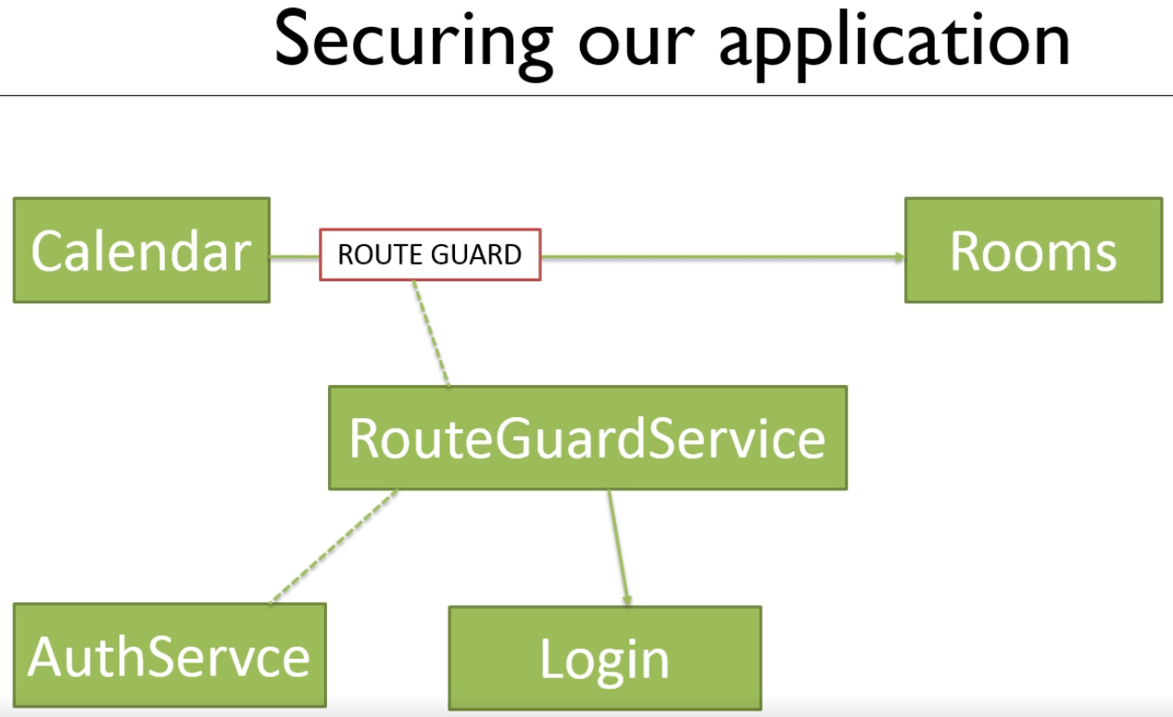

Let us code up the RouteGuardService



Implement the service

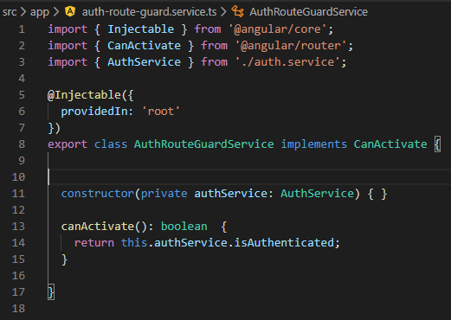

Update the app-module.ts file with a new route for the login component

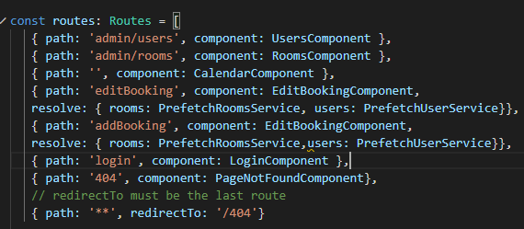

Add the protected urls with routeGuard

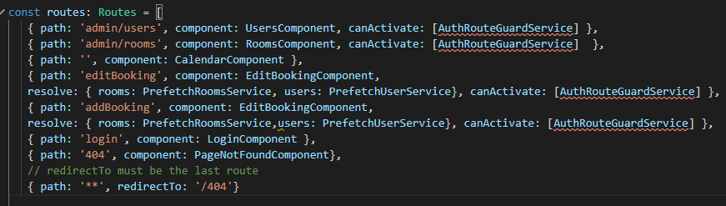

If you try to access these four urls they will not work, the user is not authenticated

Let redirect to the login component

Code this up

Add the imports first



Now code the AuthRouteGuardService

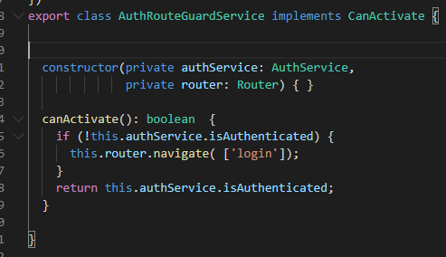

Now we can test this

If I access Rooms or Users I should be redirected to the login component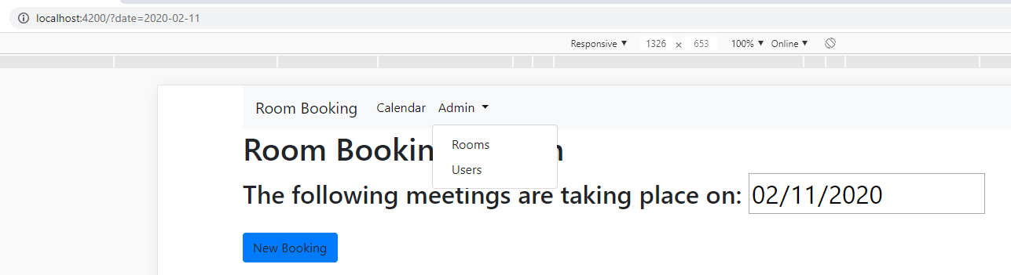

And it does

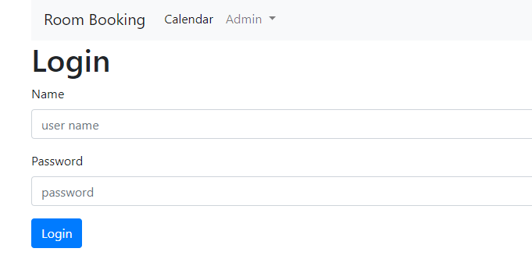

Put in the wrong username and/or password

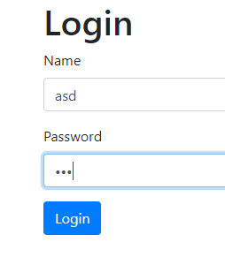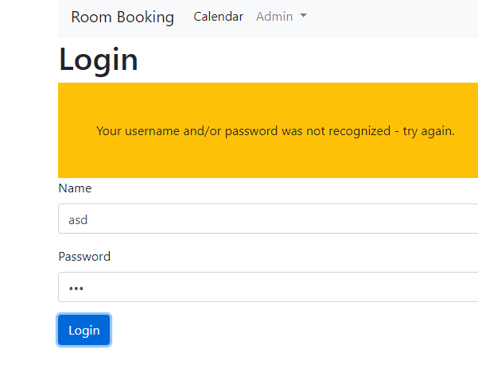

Put in the correct information: matt and secret

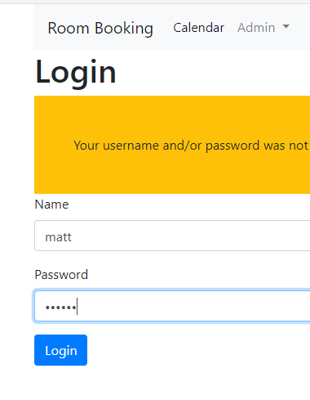

Nothing happens

So, let us capture where the user wanted to go with snapshots

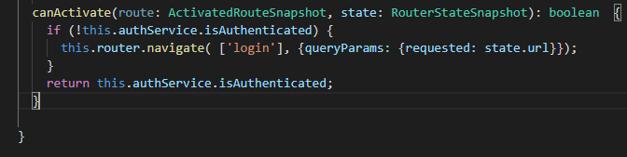

Now let us see what happens to the browser url with the new navigation

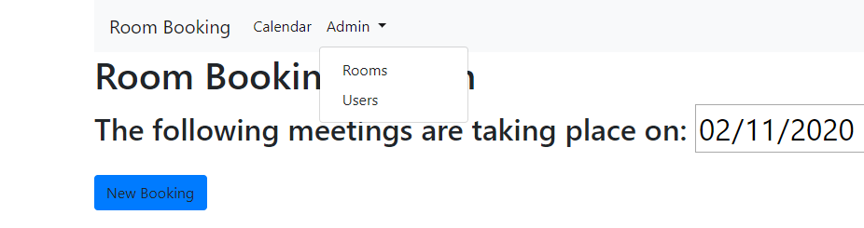

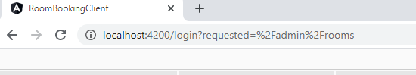

The route path admin/rooms has been captured

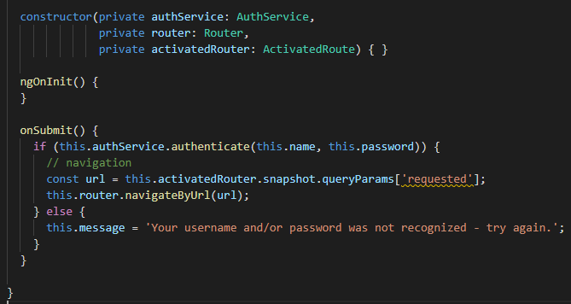

Test if the login page can route us to the correct page on successful authentication

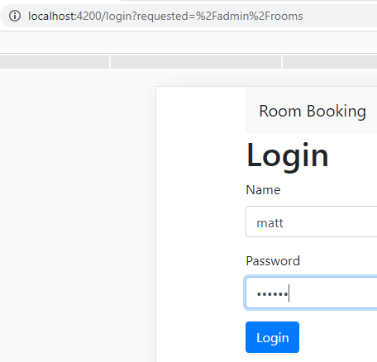

Looking at the URL we should be sent to admin/rooms

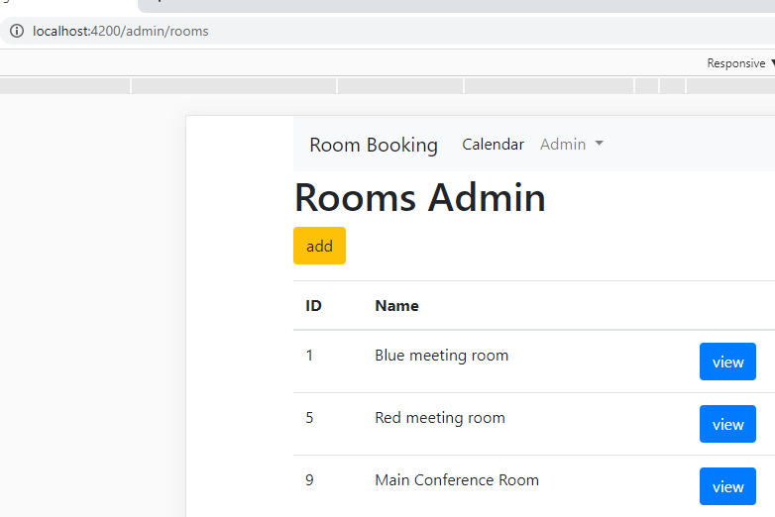

And that is exactly what happens